Graphene oxide assists in purifying water without chlorination

　　Scientists from the National University of Science and Technology "MISIS" together with their colleagues from Derzhavin Tambov State University and Saratov Chernyshevsky State University have shown a way for graphene oxide to purify water, making it drinkable, without further chlorination. "Capturing" bacterial cells, it forms flakes that can be easily extracted from the water.

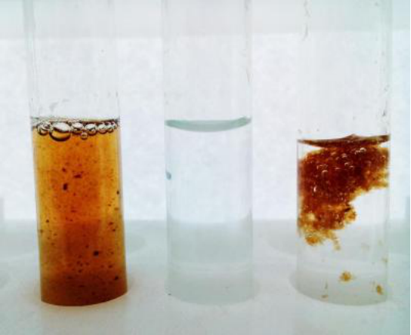

　　1) Graphene oxide, added in water 2) Water after purification with graphene oxide 3) Graphene oxide 'flakes' with bacteria before extraction

　　The team has conducted an experiment, injecting graphene oxide into solutions (nutrient medium and the saline) containing E.coli. Under the terms of the experiment, saline "simulated" water, and the nutrient medium simulated human body medium. The results showed that the graphene oxide along with the living and the destroyed bacteria form flakes inside the solutions. The resulting mass can be easily extracted, making water almost completely free of bacteria. If the extracted mass is then treated with ultrasound, the graphene can be separated and reused.

　　"As working solutions, we chose a nutrient medium for the cultivation of bacteria (it is the natural habitat of bacteria), as well as ordinary saline, which is used for injections. As a tested bacterial culture, E. coli modified with a luminescent agent was used to facilitate visualization of the experiments, said Aleksandr Gusev, one of the authors and Associate Professor of NUST MISIS Department of Functional Nanosystems and High-Temperature Materials.

　　Graphene oxide was added to the nutrient solution in different concentrations - 0.0025 g/l, 0, 025 g/l, 0.25 g/l and 2.5 g/l. As it turned out, even at a minimum concentration of graphene oxide in saline (water), the observed antibacterial effect was significantly higher than in the nutrient medium (human body). Scientists believe that this indicates not a mechanical, but a biochemical nature of the mechanism of action, that is, since there are far fewer nutrients in the saline solution, the bacteria moved more actively and was "captured" by the scales of graphene oxide more often.

　　According to the fluorescent test data, confirmed by laser confocal microscopy and scanning electron microscopy, at 2.5 g/l concentration of graphene oxide, the number of bacteria decreased several times compared to the control group and became close to zero.

　　from:https://www.graphene-info.com/graphene-oxide-assists-purifying-water-without-chlorination